Git Hands-on Lab 2 Report - .gitignore

Objective
Implement the .gitignore file to ignore unwanted files and folders in a Git repository.

Prerequisites
- Git installed and configured
- Notepad++ configured as default editor
- Existing GitDemo repository

Procedure
Step 1: Open repository
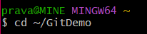
Step 2: Create log folder
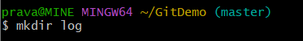
Step 3: Create .log file
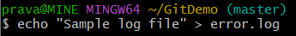
Step 4: Create file inside log folder
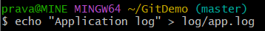
Step 5: Open .gitignore
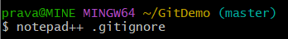
Step 6: Add the following lines
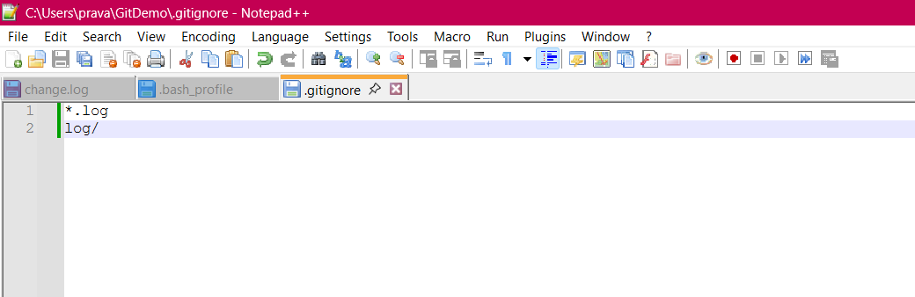
Step 7: Check status
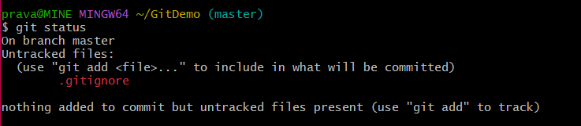
Step 8: Stage .gitignore
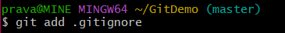
Step 9: Commit
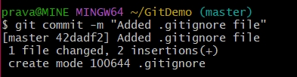
Step 10: Verify
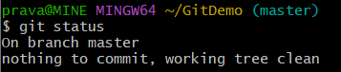

Result
Before adding .gitignore, Git status should show only .gitignore as untracked. The error.log file and log folder should be ignored.
After the commit, 'git status' should display 'nothing to commit, working tree clean'.


Screenshots Required
- .gitignore file showing *.log and log/
- git status before git add
- git add .gitignore
- git commit -m "Added .gitignore file"
- Final git status

Conclusion
The .gitignore file was configured successfully. Git ignored all .log files and the log directory while tracking only the required project files.

